**Manual Test Plan: Redditmovie**

**Run the program.**

**Go into the project file in the terminal and type “expo start” to start the program.**

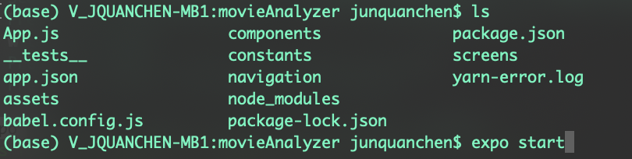

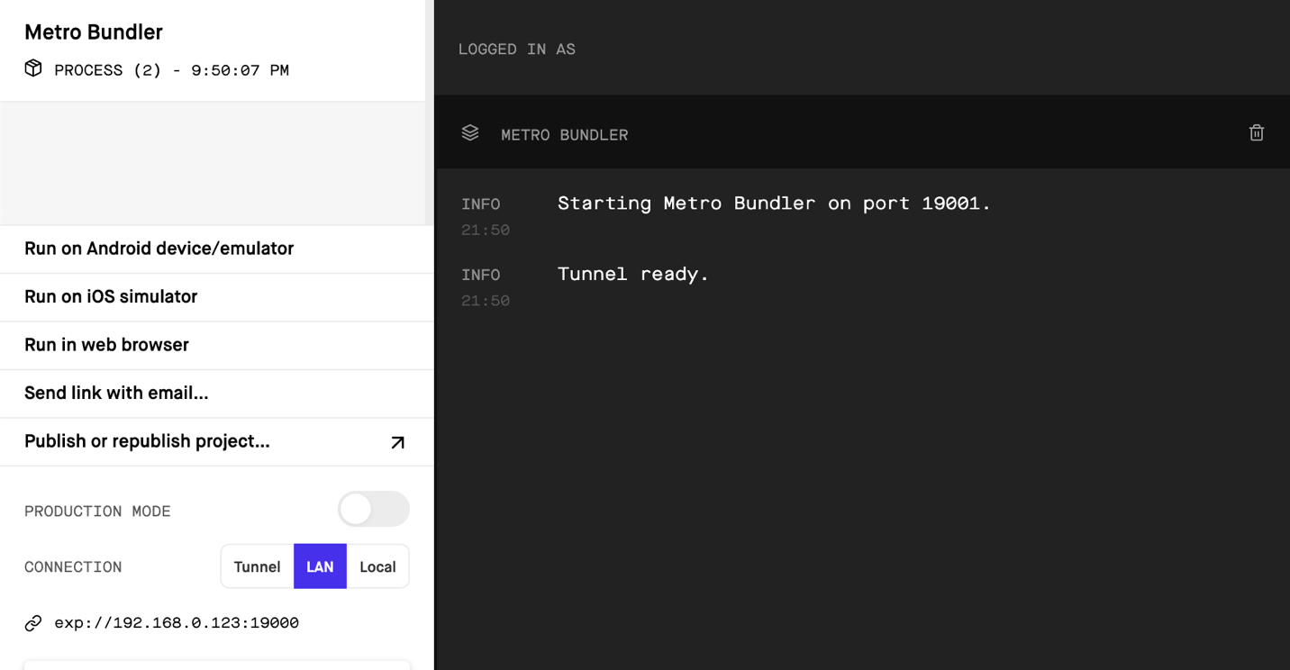

**Select “Run on IOS simulator”**

**1st: Login page Test**

**After running the program this should be the first page (Login page) show up.**

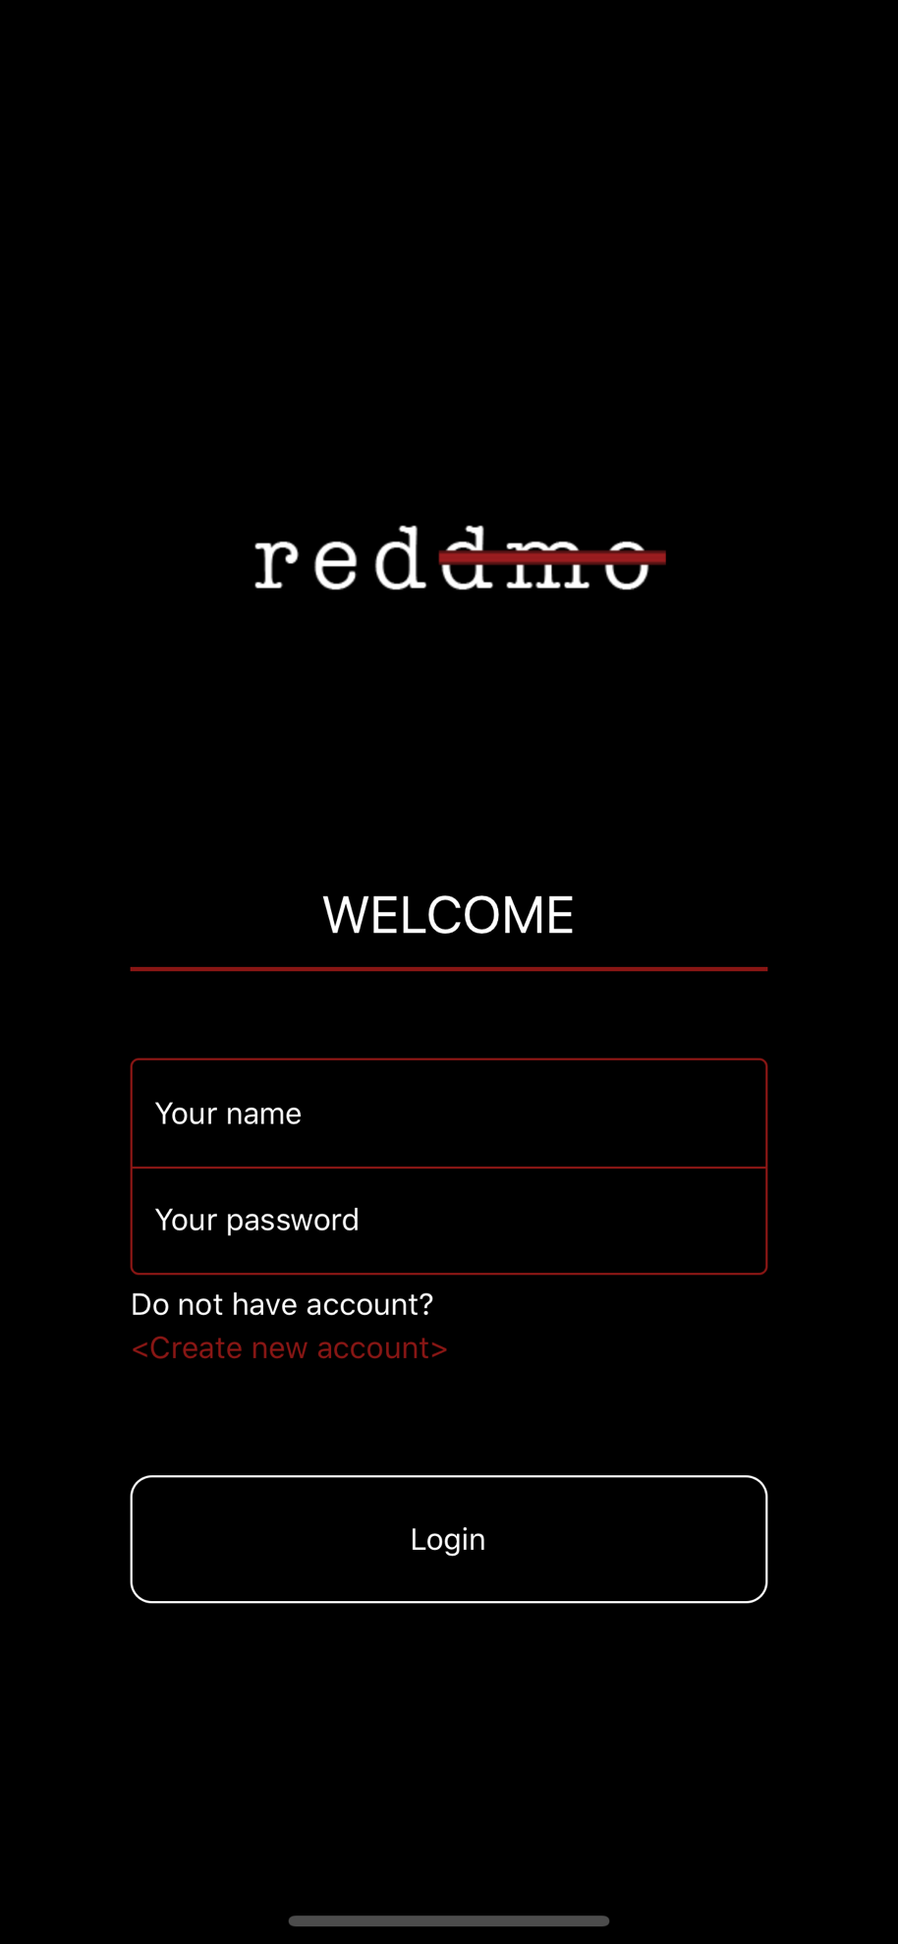

**To test the login page lets first go to the registration page and create a user with username: David and password:1234.**

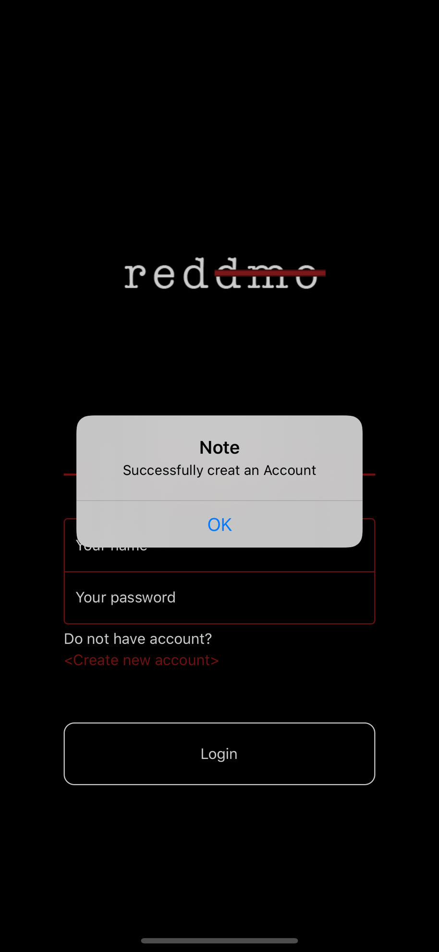

**Then** **we first test whether it will check the user has already entered the username and password.**

**If we click login without any input, an Alert will pop up like bellow.**

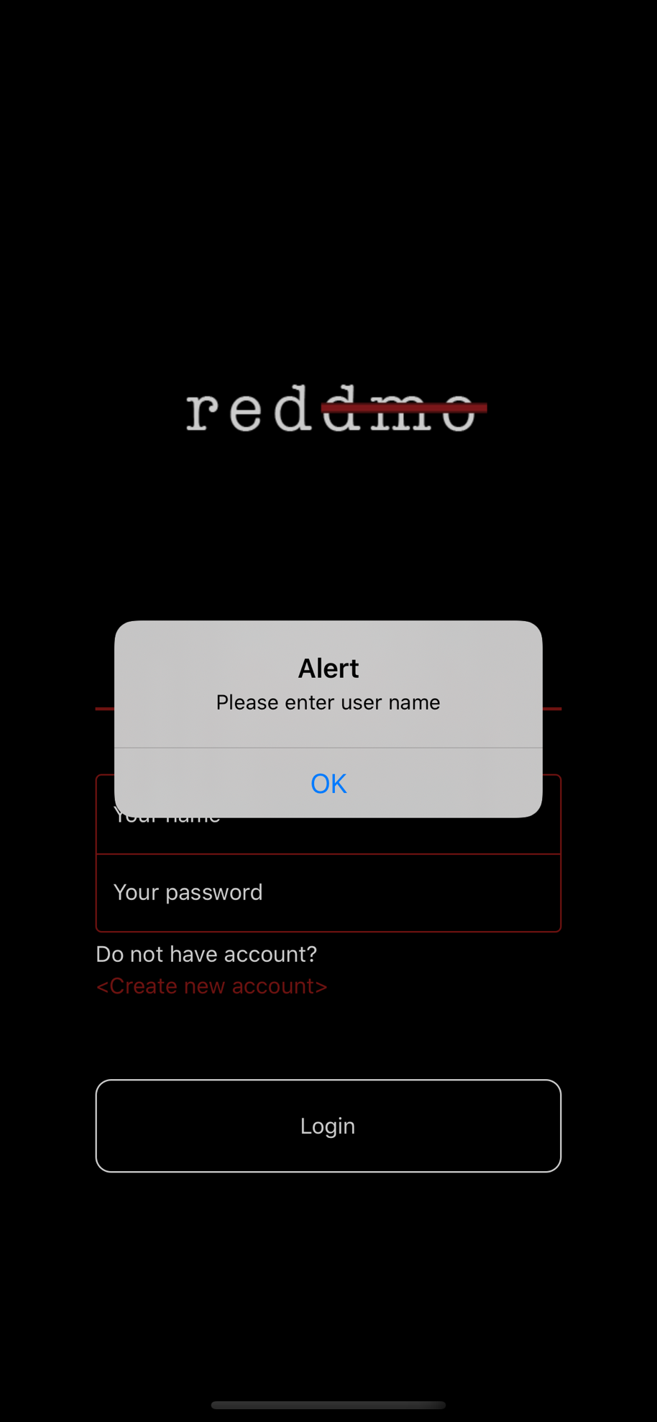

**Then let try entering a username without password. There should also pop up an alert.**

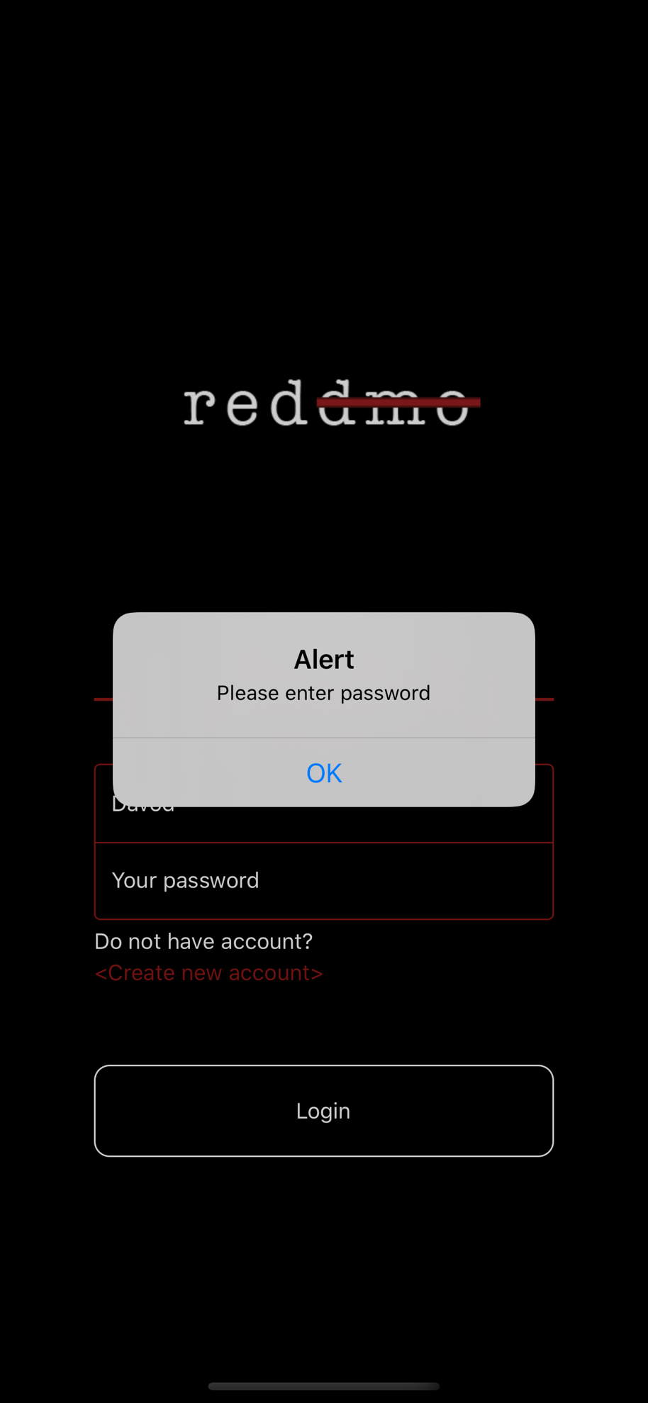

**Then let’s try entering incorrect username and password. Ex.(david, 123),(David,1234)**

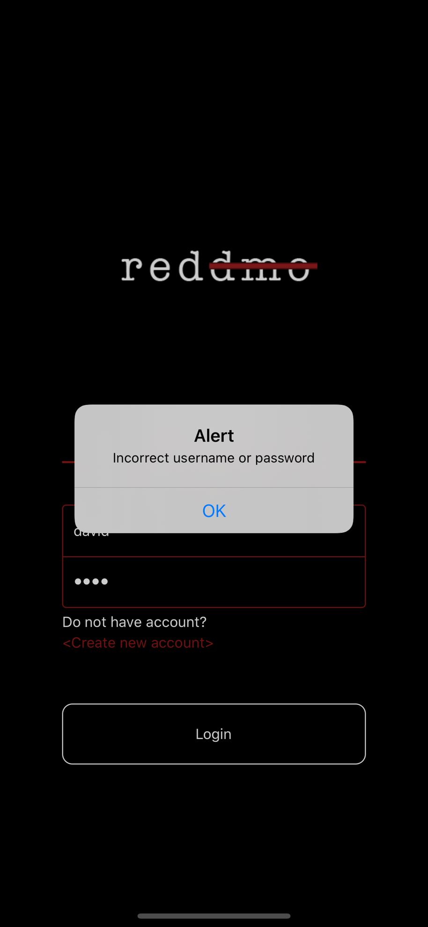

**At last, after we enter the correct username and password, we should be able to navigate to the main app page as below. Ex. (David, 1234)**

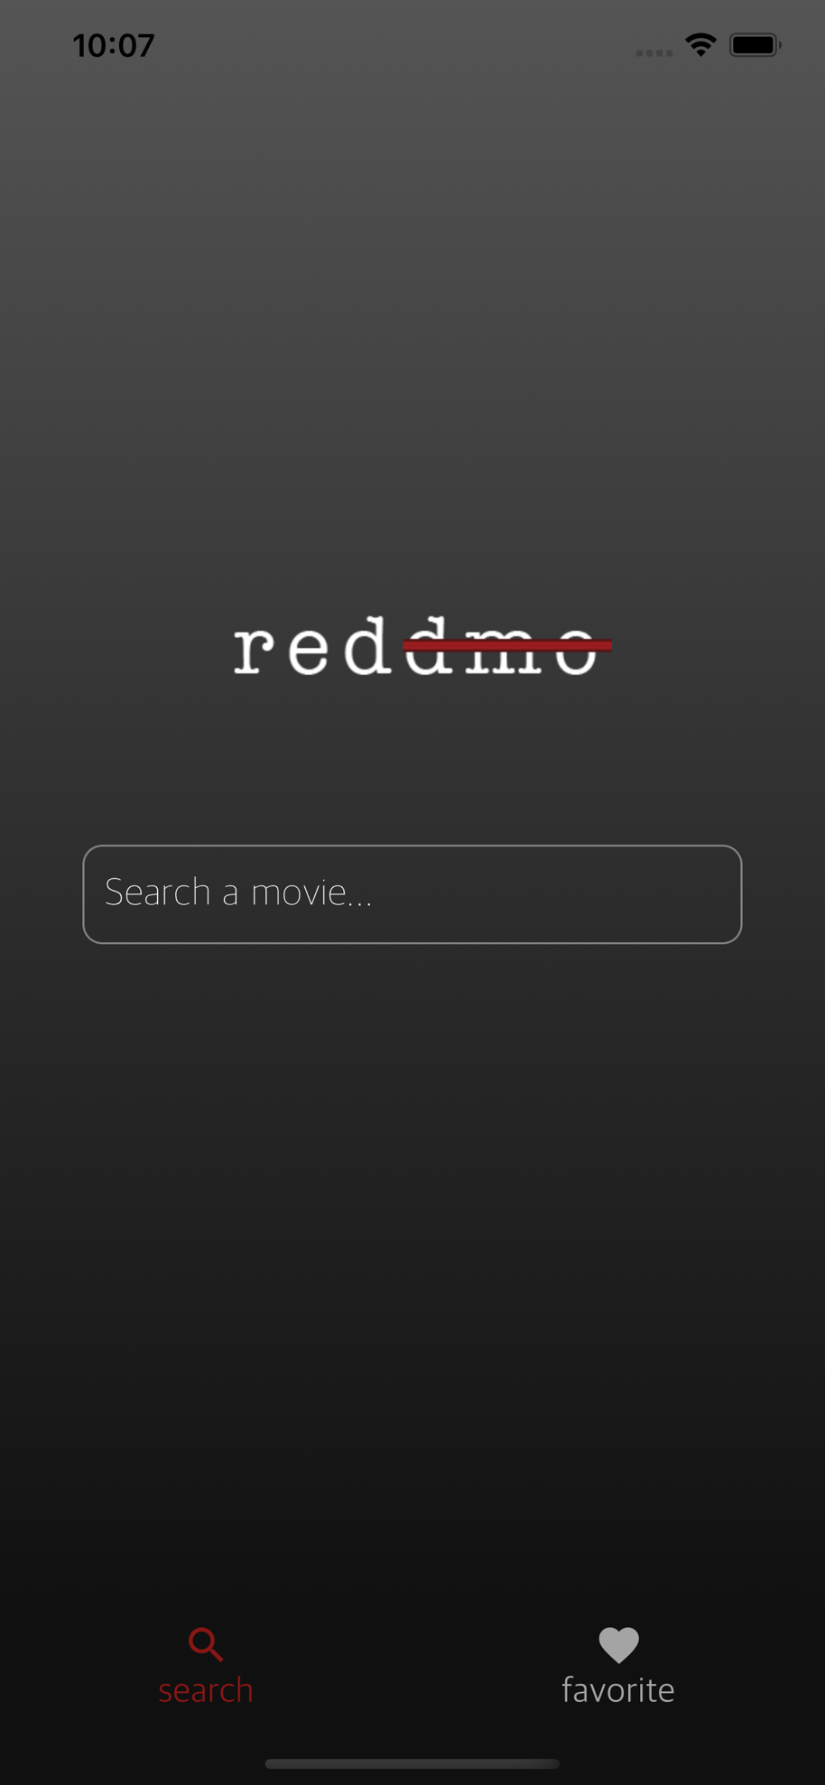

**2nd: Registration page Test**

**we first test whether it will check the user has already entered the user name and pass word.**

**If we click login without any input, an Alert will pop up like bellow.**

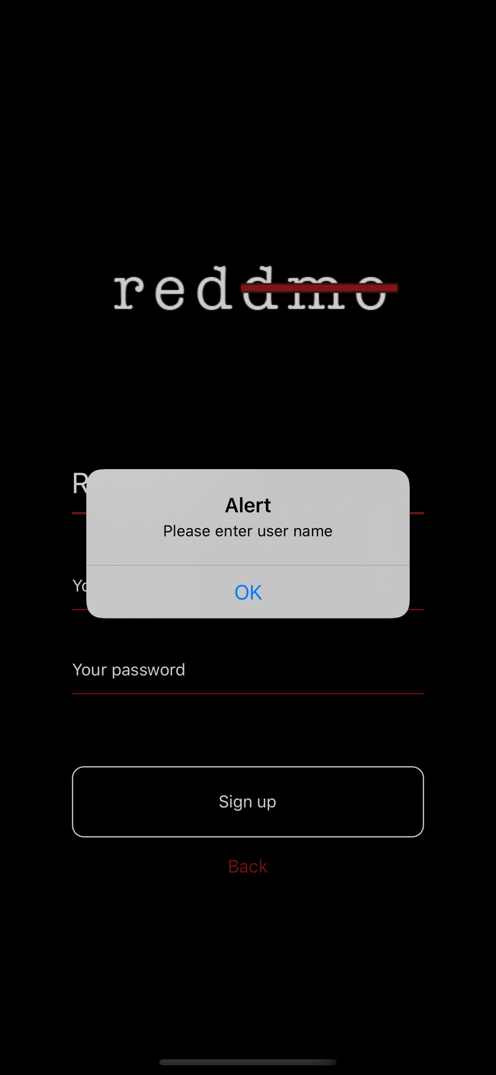

**Then let try entering a username without password. There should also pop up an alert.**

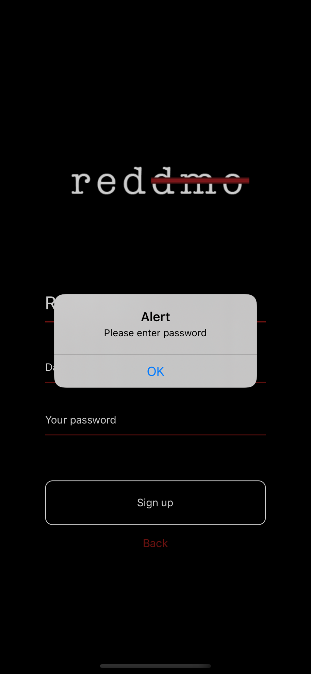

**Let’s try entering the existing username. It should pop up alert that notify user to use another username.**

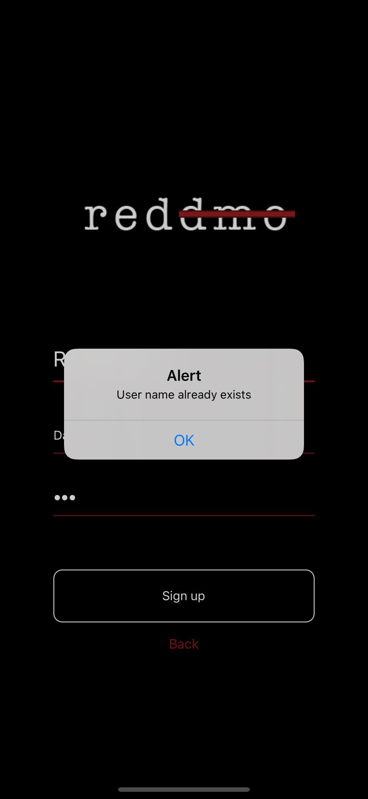

**Then let’s use a new username. Ex. junquan,123**

**You will be automatically redirected to the login page to enter your username and password.**



**Let’s use the new username and password to login.**

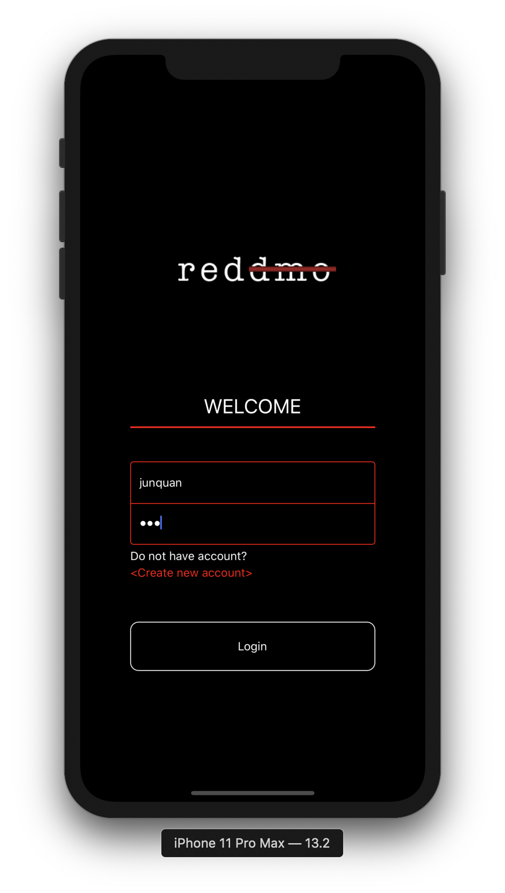

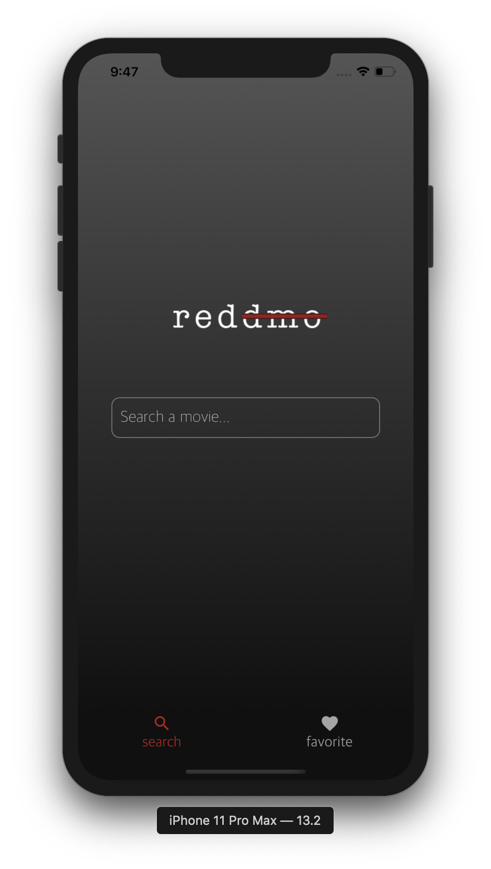

**3rd Check Mongo dB:**

**We are using mongo DB Atlas as our data cloud service.**

**If going the online Mongo DB atlas web page you can see the following data on the page.**

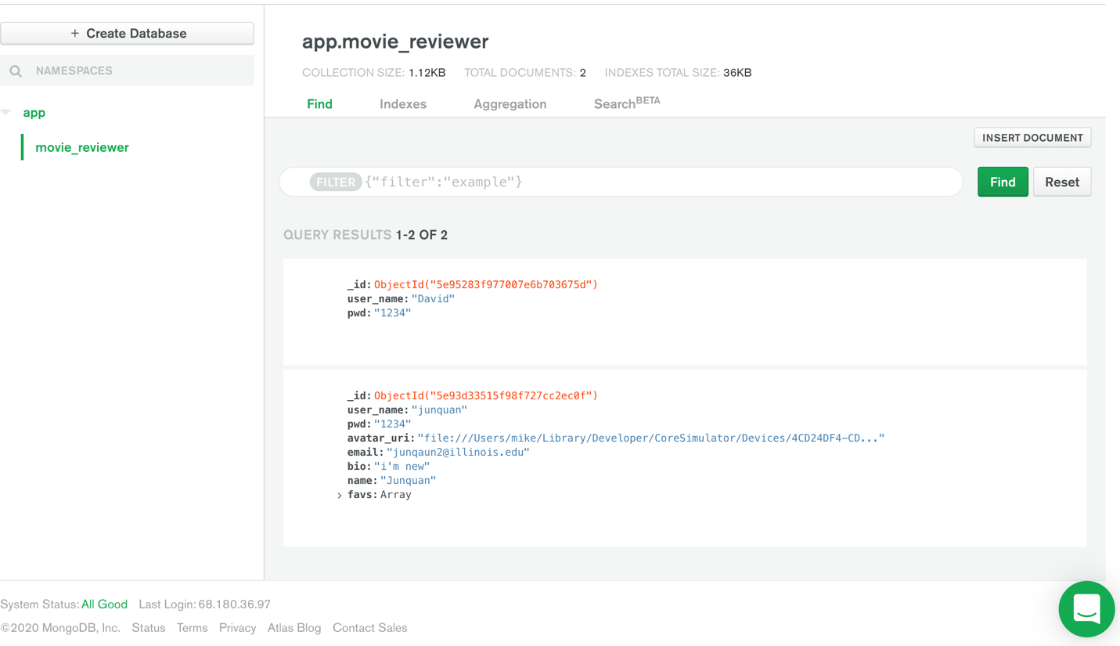

**4th: use the bottom navigation bar to go to the cinema page. Below screen should be the first page that show up.**

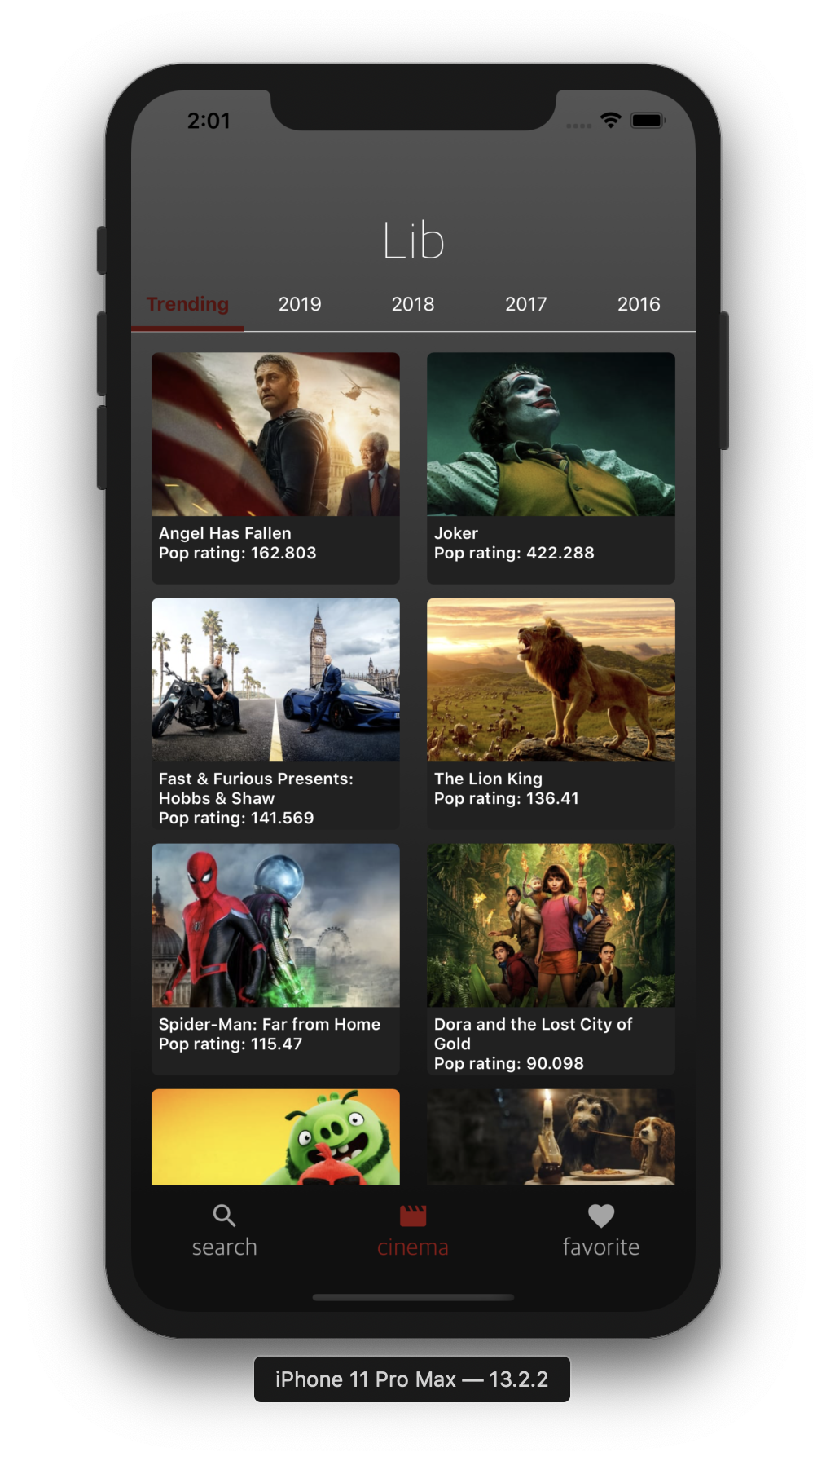

**You will see the trending movies in the trending page and you can scroll it to see more of them.**

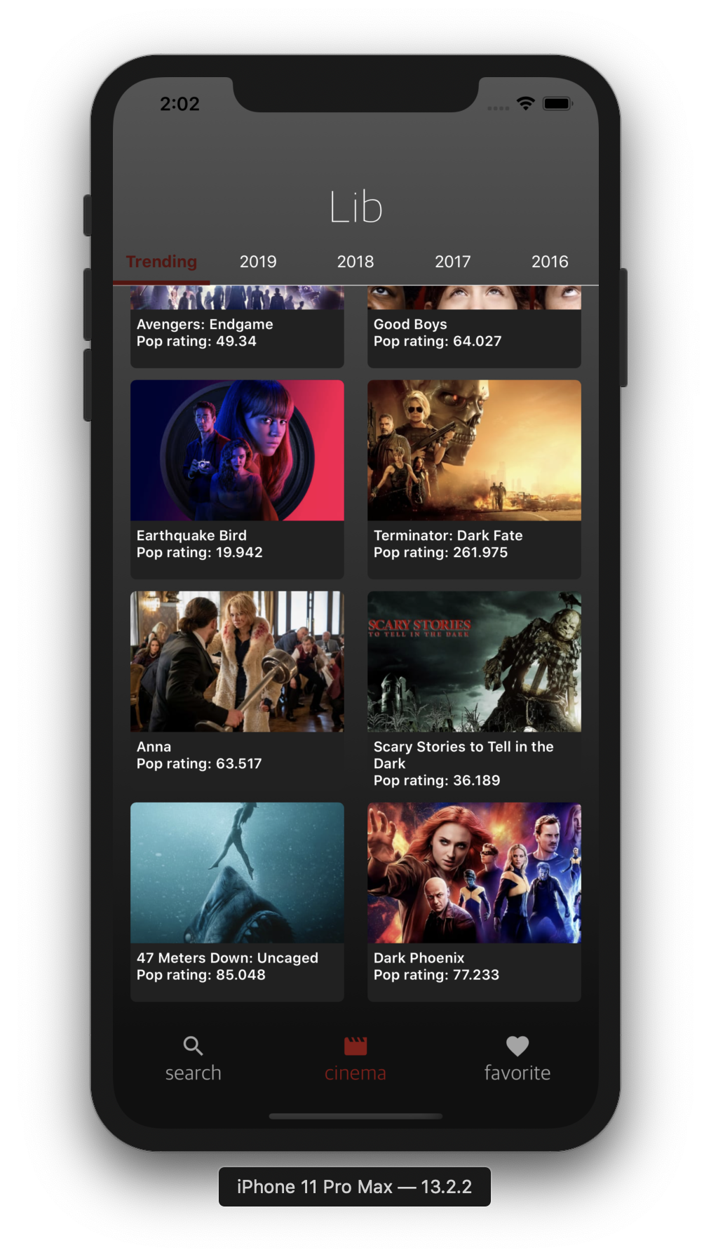

**Then click on any one of them. You should be directed to the movie detail page. And in the detail page you can click the back button on the top left to go back to the cinema page.**

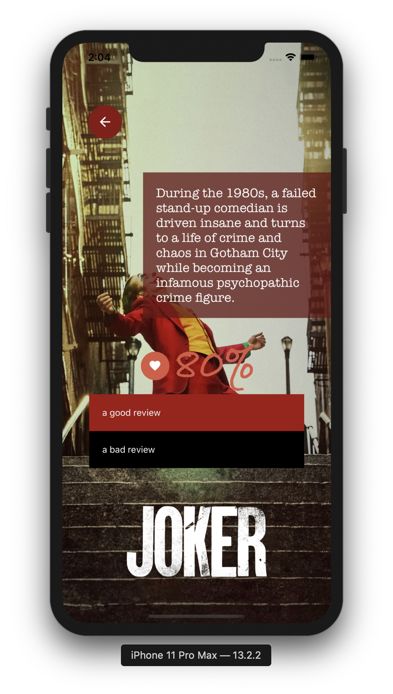

**Then try to slide left in the tab view or click on the other taps. Here let’s try slide left or click on the 2019 tap. You will see the movies list in 2019 sorted by the popularity.**

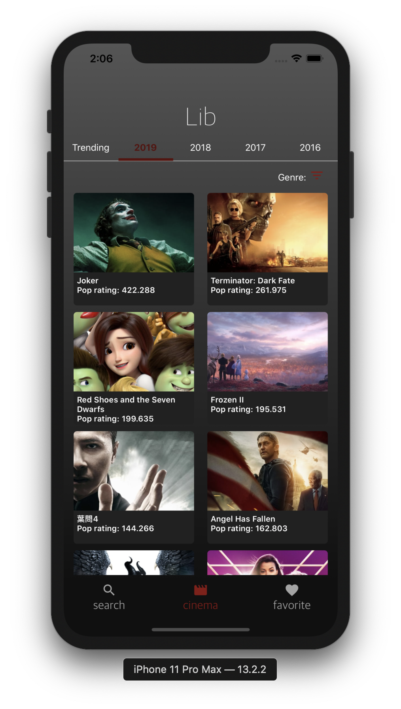

**Then try slide to left or right to make sure all of the pages can be accessed by sliding the screen.**

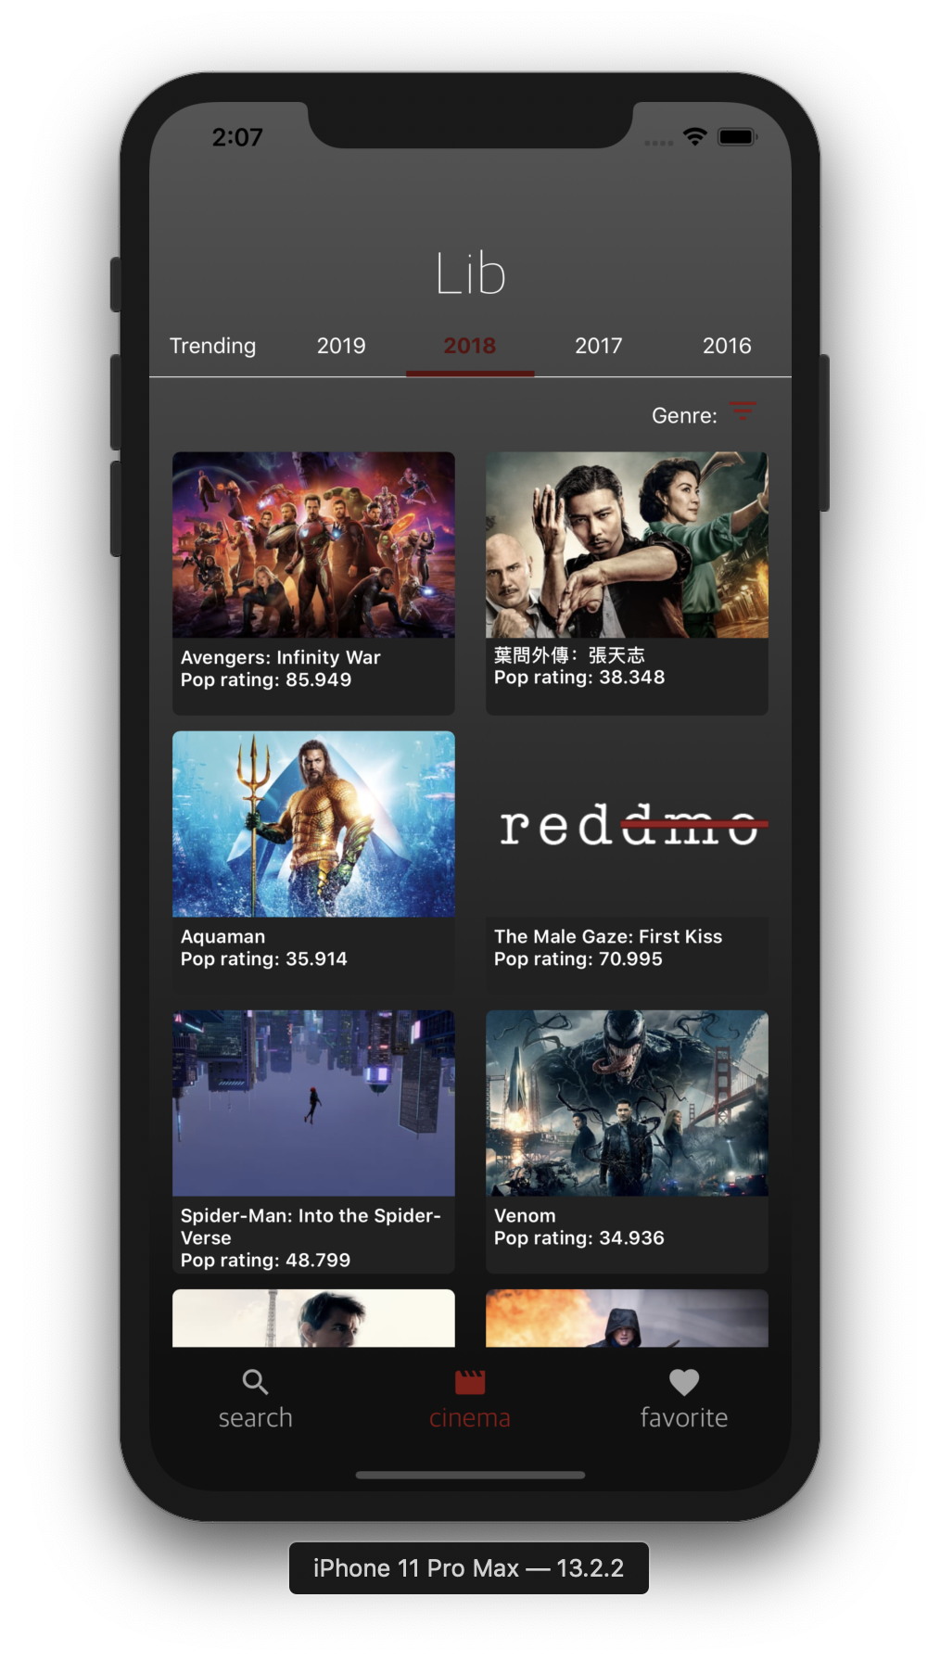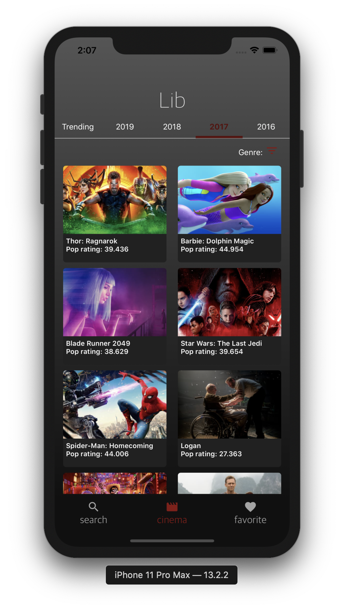

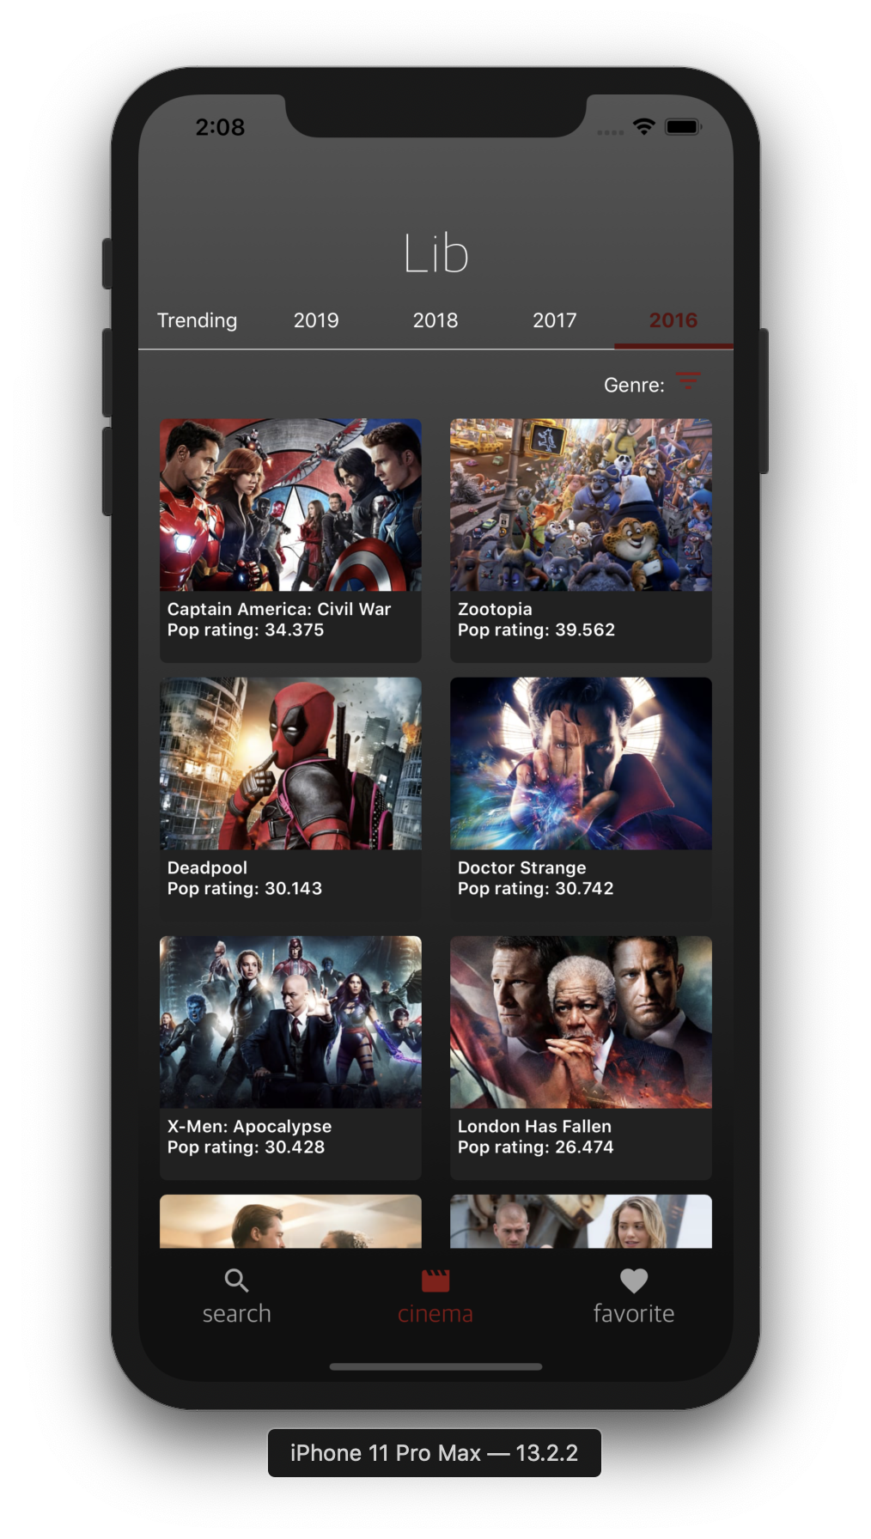

**In the 2019 movie list view, you can try scroll down to the bottom, since there are 20 movies shown in the current page. If you want to see more, you need to scroll down to the end to load 20 more movies.**

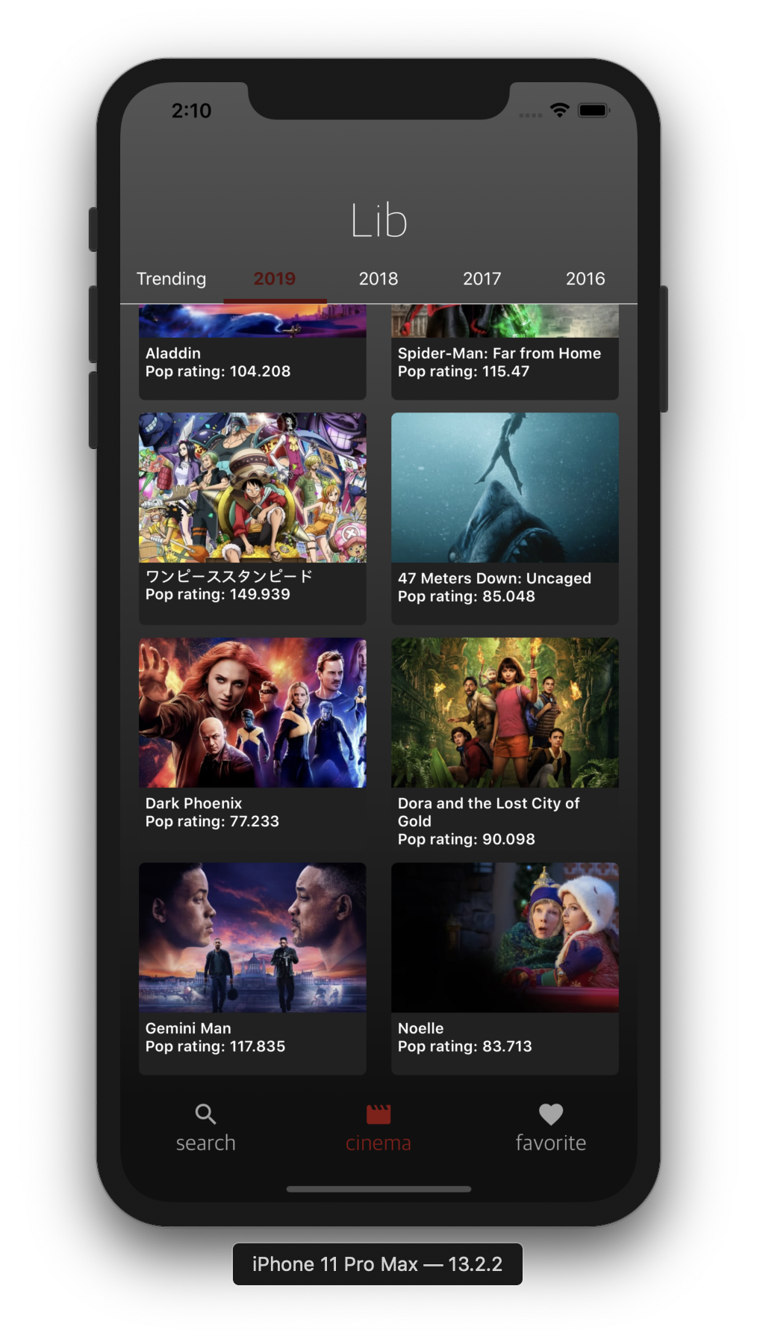

**This is the bottom of the 1st page.**

**Then you should find that there are more movies appeared below.**

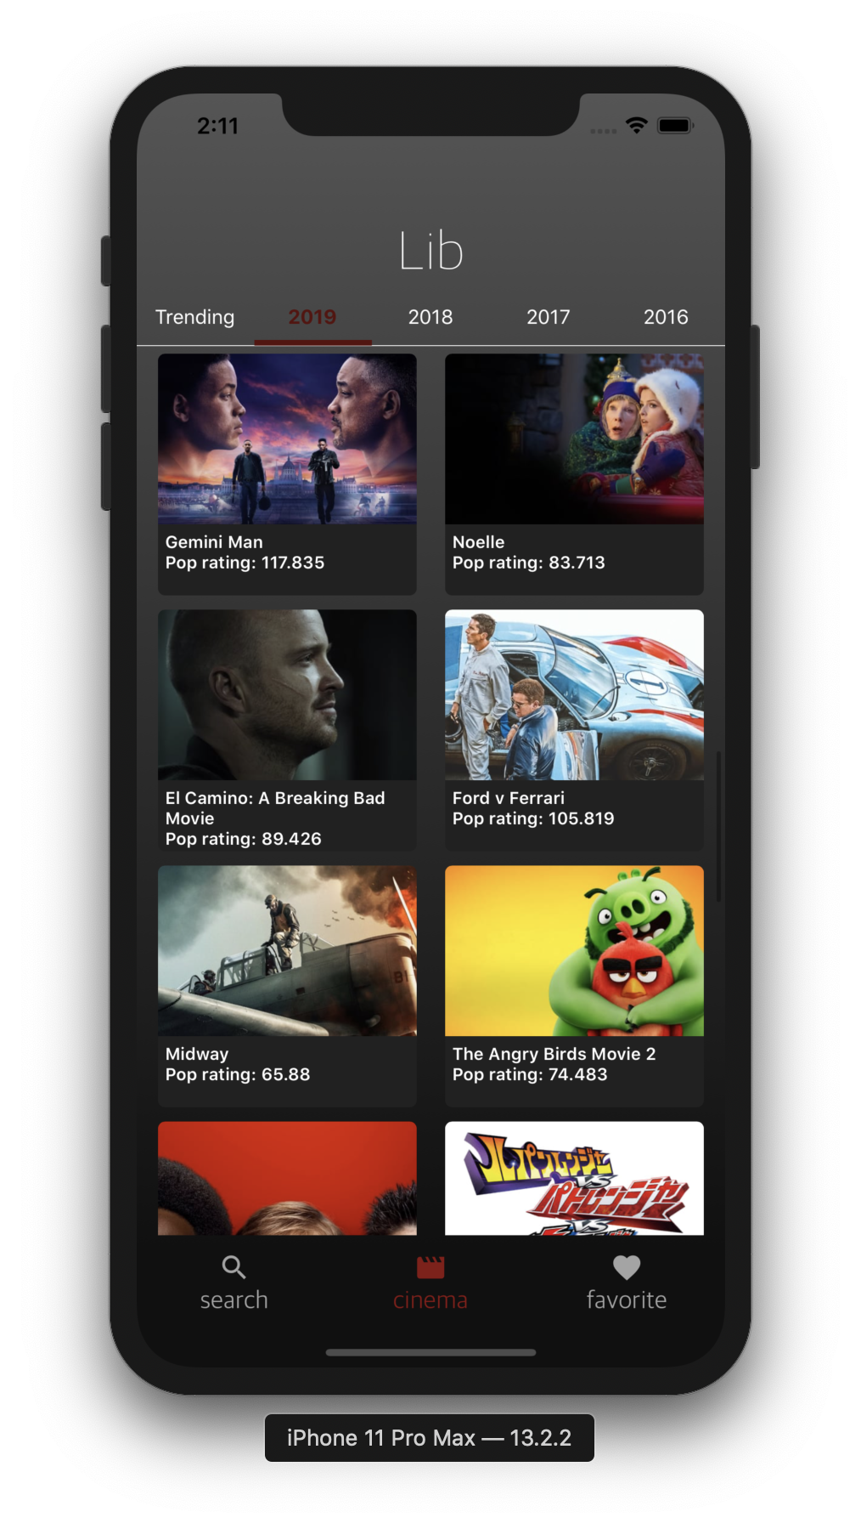

**Since the loading movies will be stored in the app after you first load them. Go to another page and go back you should still be able to see the movies you loaded before.**

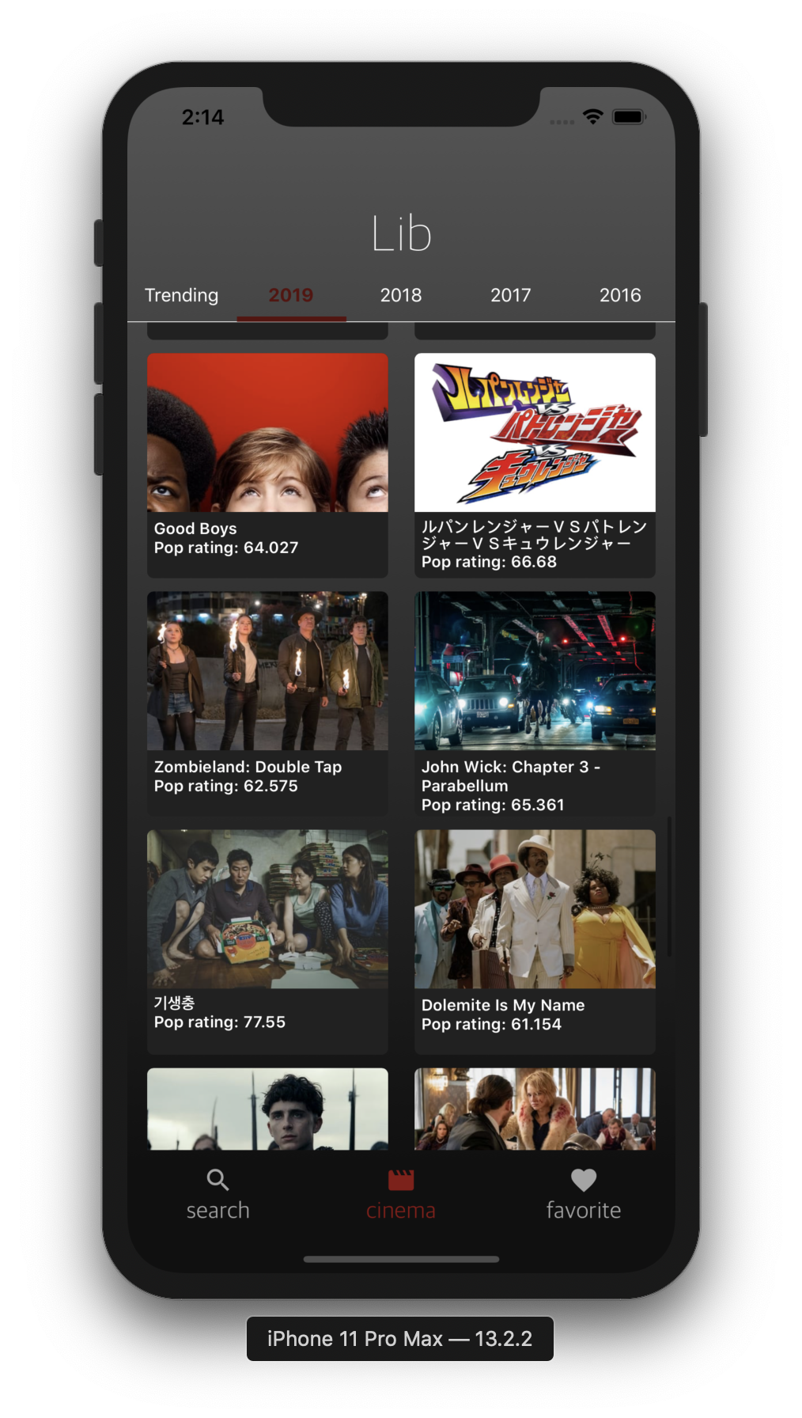

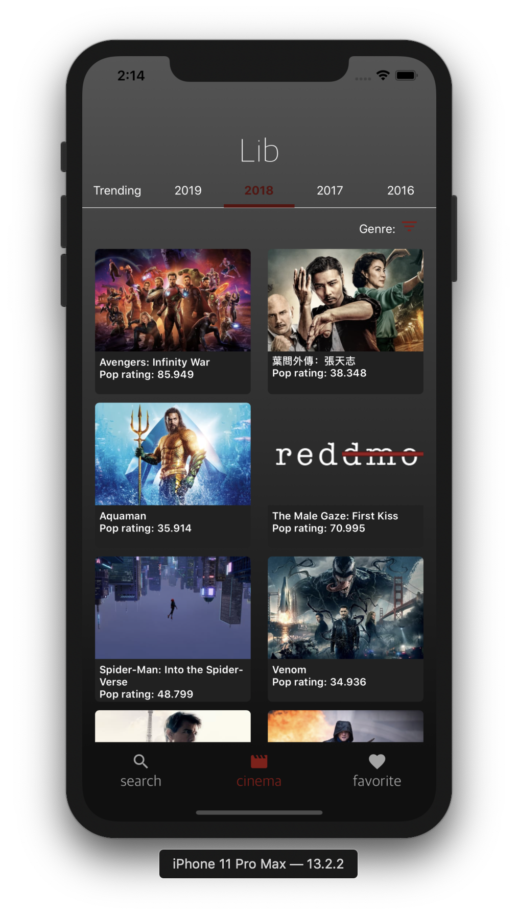

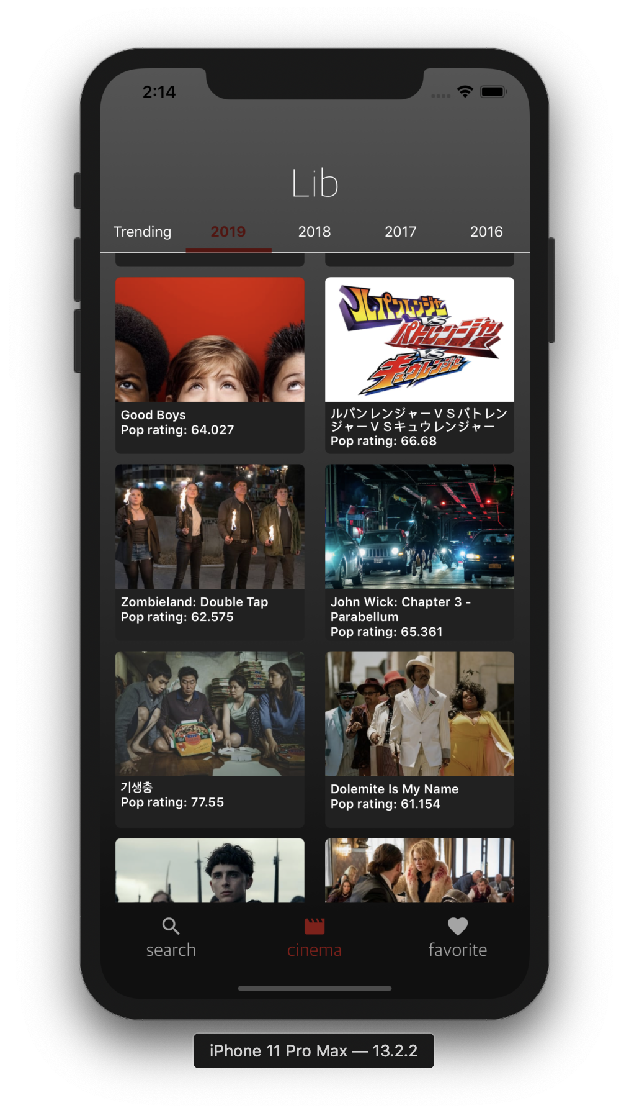

In the pages 2019, 2018, 2017 and 2016, you can see that there is a genre filter on the top right. If you click on it, it will show you the following genres: ['All', 'Action', 'Comedy', 'Romance', 'Science Fiction', 'Animation']. Click on any one of them you will see the movies in that specific genre.

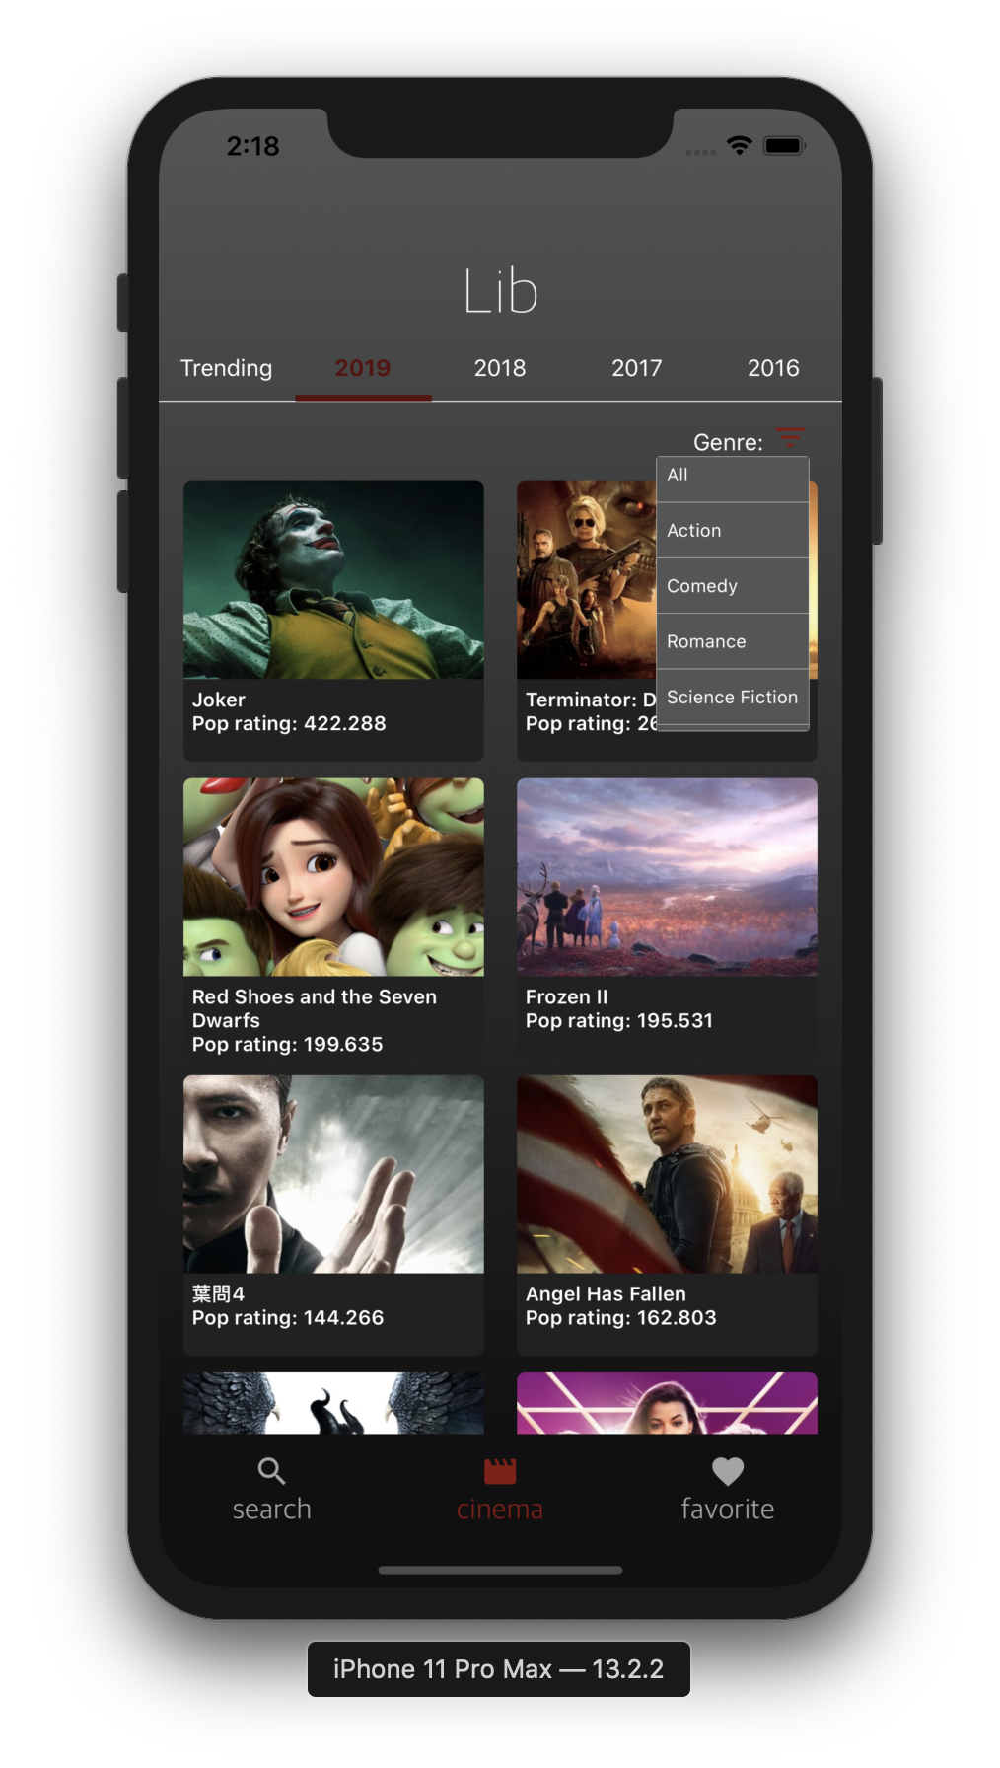

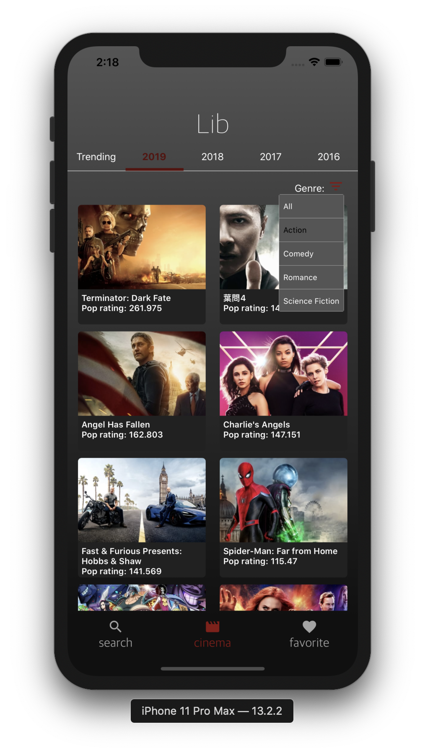

**Also if you scroll down to the bottom of the page, you will load 20 more movies in the same genre .**

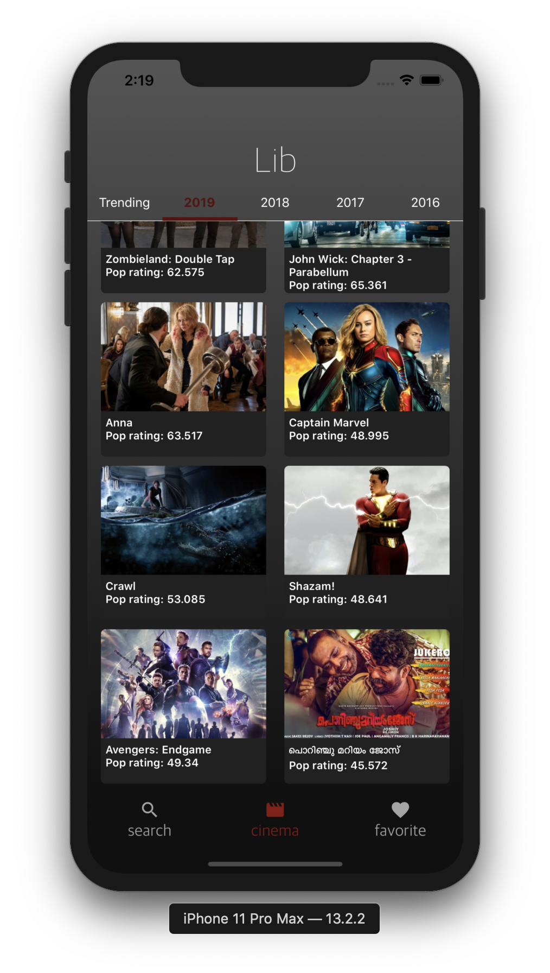

**This is the bottom of the 2019 action movie list.**

**Then you will see the 20 more movies like below.**

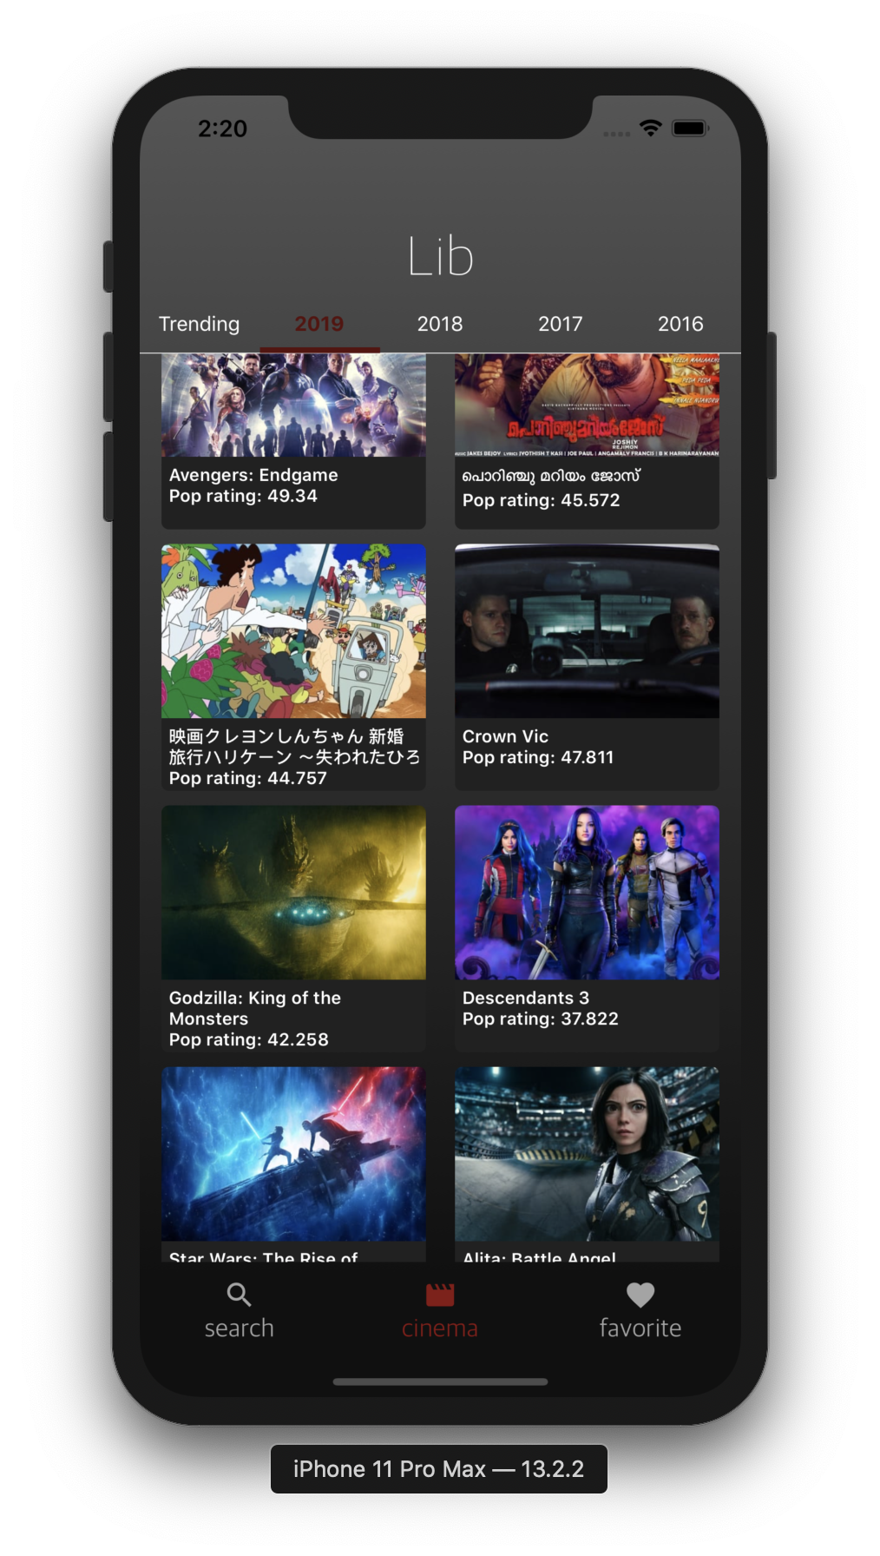

**The following features should be tested in all of the year pages(2019,2018,2017,2016) that including “Going to the detail page”, “Lazy loading for more movies” and “Filtering the movies based on the genre”.**